DAILY ONLINE ACTIVITIES SUMMARY

Date: |  | 21-05-2020 |  |  |  |  | Name: | Suhas prasad shetty
Sem & Sec |  | ₈th _{B} |  |  |  |  | USN: | 4AL16CS080
 |  |  |  |  | Online Test Summary
Subject |  |  | SMS
Max. Marks |  |  | 60 |  |  | Score |  | 45
 |  |  |  | Certification Course Summary
Course |  | AWS integrated servises
Certificate Provider |  |  |  | AWS |  | Duration |  |  | 100 mins
 |  |  |  |  | Coding Challenges
Problem Statement: Java coding problem
Status: completed
Uploaded the report in Github |  |  |  |  |  | Yes
If yes Repository name |  |  |  |  |  | suhas
Uploaded the report in slack |  |  |  |  |  | no

Online Test Details
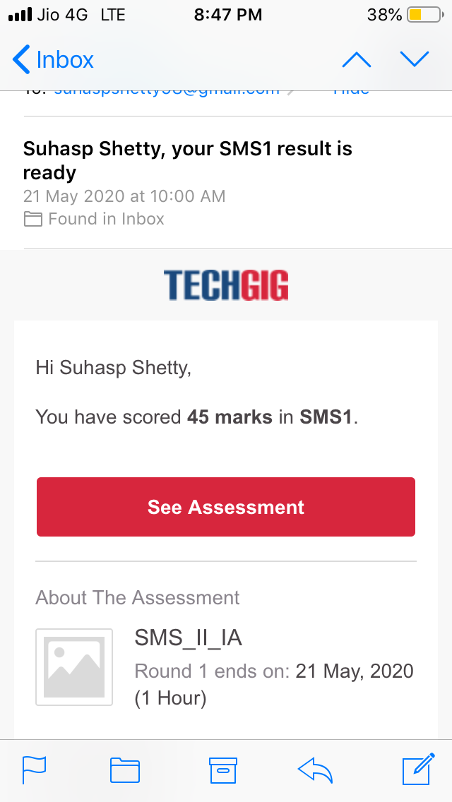

Certification Course Details:
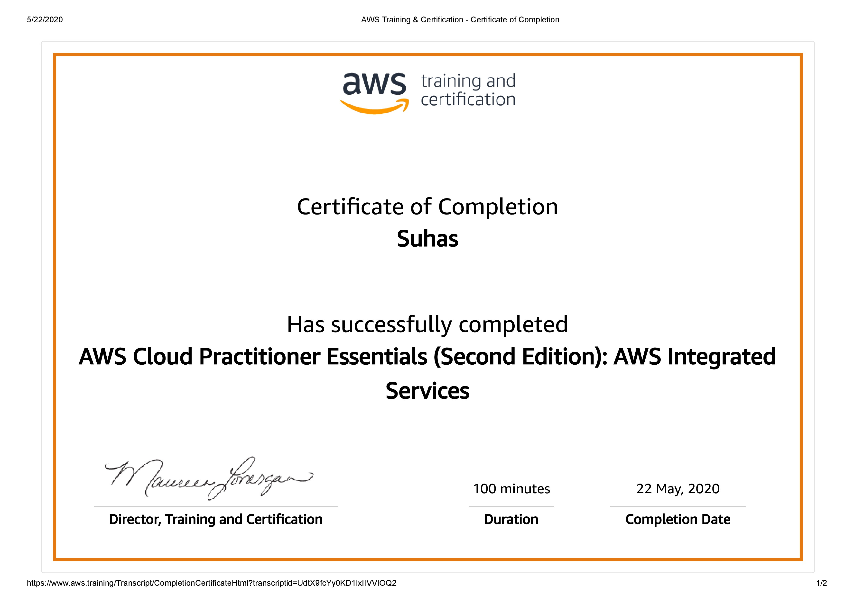

Coding Challenges Details:

Program no:1
Write a C Program to Reverse a Linked List in groups of given size.

#include<stdio.h>

#include<stdlib.h>

struct Node

{

int data;

struct Node* next;
};

struct Node reverse(struct Node head,int k)

{

struct Node current= head;

struct Node next= Null;

struct Node prev= Null;

int count = 0;

while(current!=Null && count<k)

{
next= current->next;

current->next = prev;

prev= current;

current= next;

count++;

}

if ( next!=Null)

head->next= reverse( next,k);

return prev;
}

void push( struct Node ==head_ref,int new_data)

{

struct Node= new_node= (struct Node*) malloc(sizeof(struct Node));

}

}

